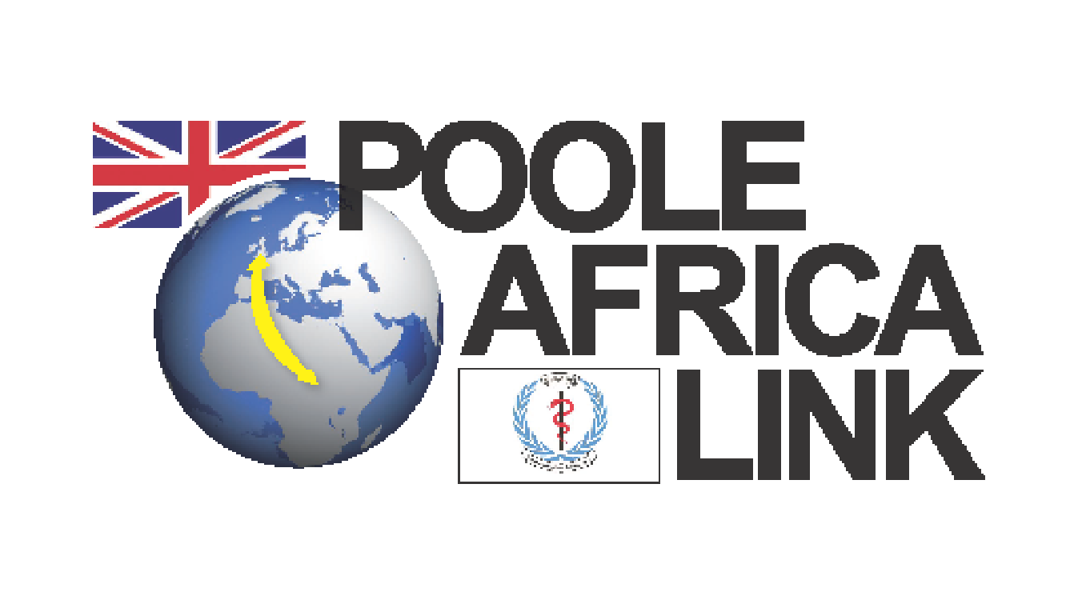

Guidelines/contract for trainers wishing to teach at
Lira University and hospitals in Northern Uganda.
January 2024

BEFORE VISIT:

- Why do you want to go to Lira? It is important to have a real desire/passion to work in a relatively under-developed country where conditions can be challenging.
- You may need to be able to teach and train with limited visual aids and minimal equipment. Not everyone who attends training will speak English as their first language.
- It is important for trainers to be aware that we visit at the request of Lira University and Hospital and we must therefore not impose our standards or methods of healthcare upon them. The visit is a 2-way process and we will learn from the staff and patients in Lira as much as they can learn from us.
- You will need the ability to be very sensitive, accepting and non-judgemental of other cultures and ways of life that are very different from our own. Visiting trainers should have a good understanding of cultural and diversity issues.
- All team members must undertake level two safeguarding (minimum) training for adults and children before they go. This should be updated every three years.
- In the two months prior to your visit you will be expected to attend team meetings to plan the training visit and read and answer e-mails appertaining to the visit in a timely manner. We work very much as a team and any ideas or initiatives that you have should be discussed with the team leader before implementing.
- Please read the previous reports and blogs on the PAL website and talk to previous trainers. .New team members may like to buddy up with a previous team member for additional support and information prior to the trip.

- All visiting trainers must understand that, whereas the Poole Africa Link may provide advice and some financial support for travel /accommodation, the Charity cannot undertake responsibility for personal safety, personal loss or the consequences of any injury or medical conditions acquired by visitors. Although annual travel insurance for the teams is taken out by PAL, this does not cover any pre-existing medical conditions and you must take out your own personal medical insurance and comprehensive worldwide travel insurance. Any ongoing treatment following the trip is not covered, as it should be provided by the NHS. Trainers will be provided with a copy of our insurance before the trip. By signing this document trainers are confirming that they have read the insurance documents and agree to the cover provided.
- The cost of taking each team member to Lira for 2 weeks is approximately £1500. All team members must therefore commit to fundraise or donate towards these expenses. The cost of the international air fare/travel is £800 and team members should raise or donate at this as a minimum amount prior to the trip. By signing this form you undertake to commit to that. It is also expected that team members will continue to support other fundraising activities organised for and by PAL.
- You should have clear written objectives agreed with your team leader and a prepared teaching plan prior to your visit, even if this is subsequently modified in the light of findings and requirements in Lira.
- Visas. Please apply online to Ugandan Embassy www.ugandagov.com
The cost is $90 (2024) which team members are responsible for paying.
Application guidance: For purpose of the visit state ‘pleasure’. You will need a letter of invitation which we obtain from Lira university, your yellow fever certificate, passport photo and photo of passport. Files need to be under 250mb.
- You will need to have current vaccinations for yellow fever, hepatitis A and B, typhoid, Covid-19 and to take prophylactic malaria tablets. Your team leader can advise on any recent changes to vaccination requirement.. Vaccinations and malarial prophylaxis are at your own expense and your responsibility to arrange. You need to be in good health to go to Uganda as the journey is long and conditions can be arduous. Please make the PAL coordinator or your team leader aware of any relevant health issues prior to signing up for the trip. Take an adequate supply of any regular medications. The ability to live in harmony in close conditions with other team members is vital.
- Ugandan travel advice including any Covid-19 regulations must be followed.
- Ideally team members should travel on the same planes from UK, ensuring arrival in Entebbe at the same time and as a team.

- PAL logo t-shirts and caps are available for purchase prior to the trip and should be worn during the journey to and from Lira. Burgundy scrubs are provided by PAL and worn for teaching at the university and in the hospital. They should be returned in clean condition following the trip. Lost scrubs will be charged for.
- Team members will be expected to carry items of medical equipment in their luggage. You should try to keep your personal luggage to around 12-15kg. Do not take valuable items of clothing and jewellery.
- Mobile phones: All team members need to carry a phone during the trip to keep in touch with each other via Whatsapp. We also have two Ugandan phones.
- Team debrief takes place following each trip and it is important that you can commit to attend this.

DURING VISIT:
- It is the role of the Team Leader to try and keep the team safe and healthy and also to maximise opportunity to use your expertise and teaching skills. They will need your support to achieve this.
- During the visit to Lira the team members will write a daily blog and post on the PAL face book page/twitter feed.
- Living accommodation/facilities may be fairly basic and the weather can be oppressively hot and very wet depending upon the season. Only drink bottled water. Do not eat salads as you cannot be guaranteed they have been washed in bottled or filtered water.
- You must commit to at least 2 weeks in Lira, plus travel time. During the visit you may be working up to 6 days a week, and this may involve evening teaching and/or preparation.
- You must undertake not to drive in Uganda or travel on ‘boda-bodas’.
- Road travel in Uganda can be hazardous. Trainers must agree to always wear seat belts and where provided use three point seat belts rather than two.
- PAL will fund internal travel, bed and breakfast and evening meal at a hotel in Lira. Trainers are responsible for own lunches, any meals taken outside of hotel (usually four), meals in transit and alcoholic and soft drinks excluding water. If the team undertakes a trip on their day off it is also a personal expense.
- Photography: Always get prior permission (where possible in writing) to take photographs. Photographing public facilities/utilities requires a Ministry of Information permit. Never take photos in the vicinity of airports.

AFTER VISIT

- On return you will need to prepare a written report as a word document of your visit within 2 weeks including training documentation.
- In order for the Link to be sustainable it is vital that all team members commit to assisting with logistics and fundraising both before and after their visit.
Finally, this will be a very rewarding, humbling but enjoyable experience and you can make a difference. We will set up a debriefing session after the visit which you will be required to attend, and we hope that you continue your involvement in the project, including disseminating information and fund-raising after your return. Thank you for your involvement.
Dr Antoinette McAulay PAL chair
Dr Frankie Dormon PAL Medical Lead
Hilary Fenton-Harris PAL Co-ordinator
Telephone: 0300 019 8182/ 07900240625
hilary.fenton-harris@uhd.nhs.uk
www.pooleafricalink.org.uk

Registered charity no 1153530
I have read and understood these guidelines

Signed ………………………………. Trainer
Name ………………………………...
Date…………………………………..

Witnessed by team leader or PAL co-coordinator

Signed……………………………………
Name…………………………………….
Date………………………………………

