One of the main objectives during this visit to Lira University was to provide a ‘PROMPT like’ course (Practical Obstetric Multi-professional Training) for the midwifery students. Our team consisted of one obstetrician, one midwife, an intensivist, a neonatal consultant and two emergency treatment doctors. The stations were to consist of a Sepsis, neonatal resus, breech birth, eclampsia, PPH (postpartum haemorrhage) and shoulder dystocia.

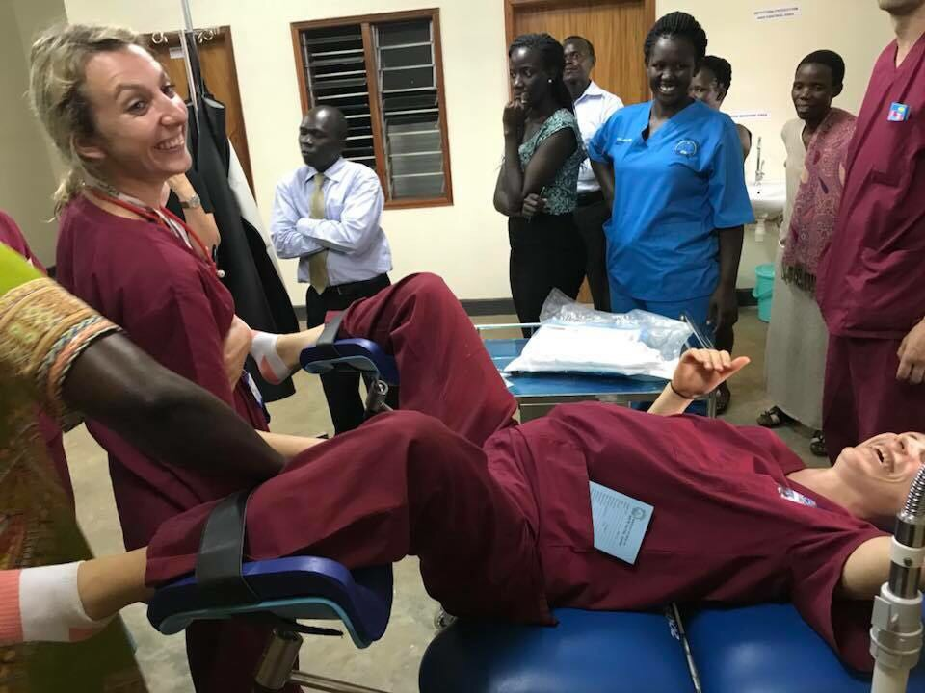
The non-obstetric/neonatal members of the team did a fantastic job undertaking crash courses in Shoulder Dystocia and maternal resuscitation in order to cover all 6 stations for the afternoon.
Kate getting into the spirit of things…

The challenge was ensuring that the facts and figures provided were pertinent to Uganda and that the solutions offered were feasible within the resources available whilst maintaining the spirit of ‘PROMPT’ in providing excellent care.
Shona getting more than she bargained for from a willing volunteer…Will averts his eyes…
The day went well with nearly 50 students and staff arriving for a packed day-long session on their day off (Saturday).
Will averting his eyes as Shona gets more than she bargained for from a willing volunteer midwife!

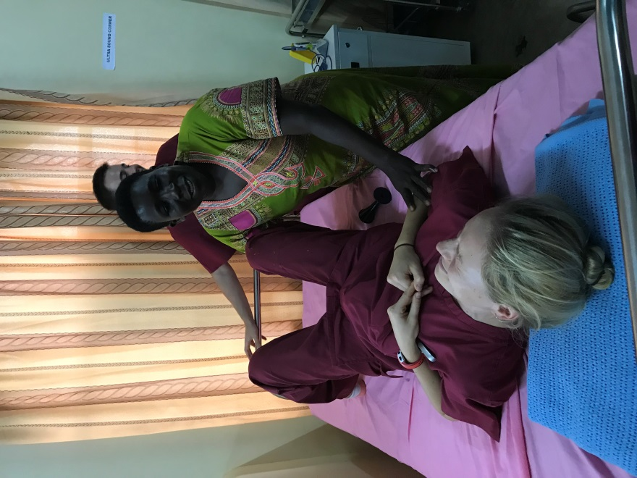
The morning consisted of a faculty demonstration of a poorly managed eclamptic fit culminating in the death of the woman as an introduction to the purpose of the course. Further classroom teaching on Maternal Sepsis, Eclampsia, PPH, The deteriorating patient and Anaesthetic complications ensued with a follow up faculty demonstration of a well led emergency scenario demonstrating good communication and allocation of tasks.
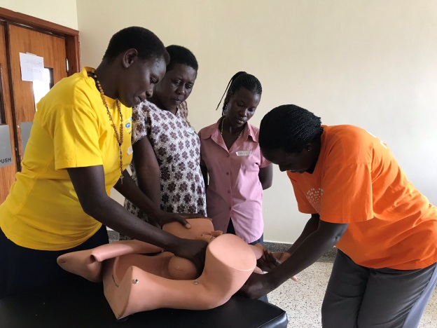
This set the scene nicely for the afternoon work stations. The team provided refreshments to the students in the form of cold sodas to enable them to soldier forth with the afternoon.
Breech Work Station…

Both the faculty and the students/staff were exhausted at the end of the day but very happy to receive certificates and have a photo with the team. (Insert photo) 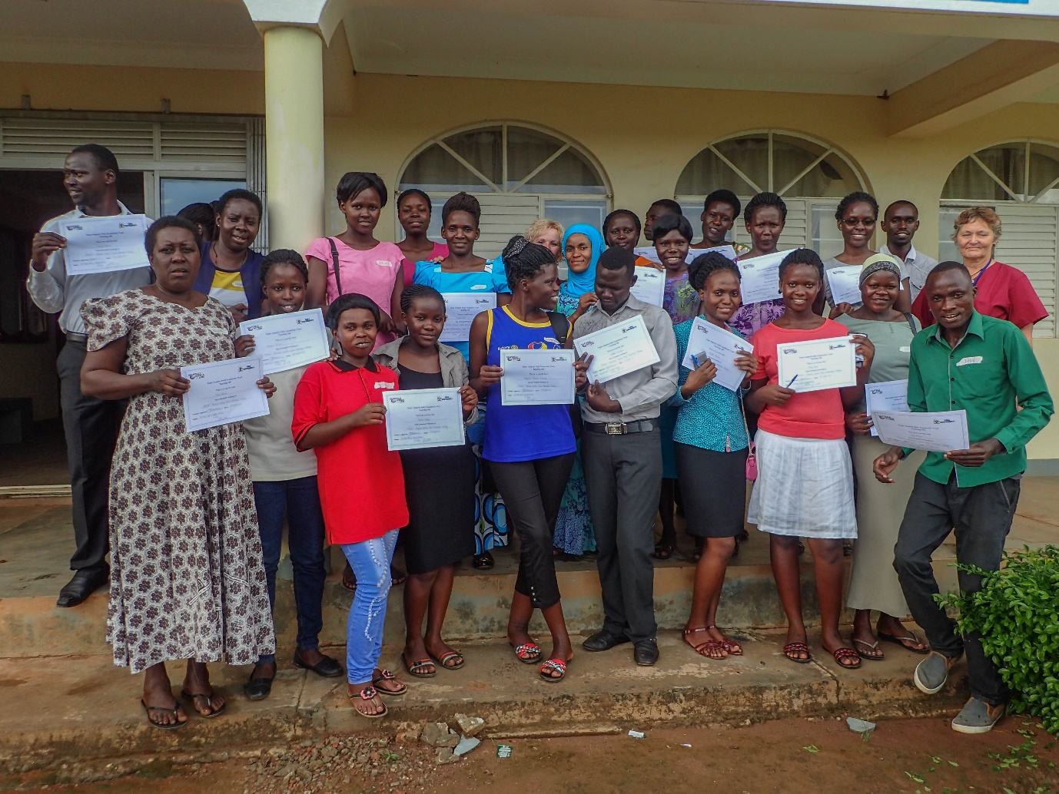

The feedback was fantastic with the only negative feedback being about the amount of information we crammed into one busy day.

There were lessons to be learned for next time, including better preparation of paperwork to enable those not familiar with the course to feel more confident providing it. However, all in all a successful day!!!!

INDIVIDUAL TAUGHT SESSION FEEDBACK RESPONSES

WORK STATIONS INDIVIDUAL FEEDBACK RESPONSES

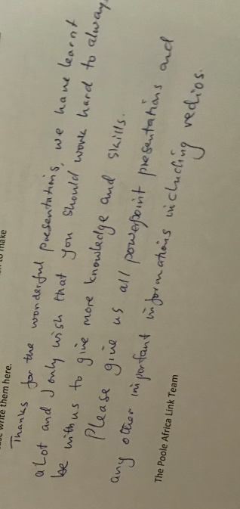
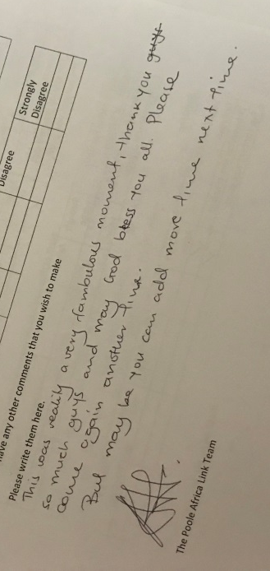

‘I had a wonderful day. I have learnt a lot and I believe I can handle obstetric emergencies. Am very greatful for your efforts towards our learning. Thank you very much.’
‘It was a very nice session. I really the practical part of it….It was a lovely and great team, please come back again to equip us with more knowledge to reduce these high maternal mortality in our country’
‘I wish you could keep on helping us like this, we would be a very good and knowledgeable midwives’
‘You guys teach exactly what we need to change the world. I endlessly say thank you.’
‘Well done there is need for continuous practice (us students).
‘I would like to thank you for imparting the knowledge to us, the students, and we pray that you continue with the same spirit so as to improve on the maternal life’
‘The sessions were so interesting and a lot of knowledge and skills have been got. It should be a continuous hands on skills like this for us to understand better.’
‘Your time of stay could be possibly increased to about a month so that we would have more time for practical experience with you guys.’
‘This training has been very important and it has transformed our knowledge and skills and I hope that it will make our practice simple also should be able to mentor others. We request to come back again next time. Thank you.’
‘It has really been a beneficial training so thanks a lot to the team.’
‘The session was extremely good, I learnt a lot from the doctors of Poole Africa Link.’
‘The sessions are really practical and wish you keep coming to training always.’
‘I loved all the scenarios and sessions. The were greatly educative, I learnt a lot.’
‘Keep it up because we learn new skills’
‘I wish next time you bring hard copies for references for our future management of our patients on the wards’
‘All the session were so perfect and very relevant for our carrier. We send our guatittude to you and request for your help more and more’
‘I love the sessions. It was so interesting and has given me a lot of practice skills and knowledge. Thanks a lot to the Poole Africa Link team, wish they keep coming to guide us.’
‘I would like you to leave us with some of the guidelines such as shoulder dystocia steps, vaginal breech delivery’
‘I priciate your time with us both in the university and the hospital. We pray you come back again.’
‘Please if all of us could be availed with copies of the guidelines. Consider us again next year for this skills training. Thank you for the certificates’.
‘It was a very interesting interaction although time was short, yet we would like to have with you more practical scenarios. We appreciate you for the time’.
‘The session was quite comprehensive, there is need for handout/soft copy of the information to help always consult.’
‘Thanks for the wonderful presentations, we have learnt a lot and I only wish that you should work hard to always be with us to give us more knowledge and skills. Please give us all powerpoint presentations and any other important informations including vedios’.
‘This was reality a very fambulous moment, thank you so much you guys and may god bless you all. Please come again another time. But maybe you could add more time next time.’
‘These sessions have been wonderful and so knowledge rich, I just wish we could have them more often, thank you very much.’
‘An interesting/enjoyable day. Please come again’.
‘Am so greatful to Poole Hospital NHS Foundation Trust teaching link. I want to say, I have benefited a lot. Again thanks. My only request is to give us enough time for content delivery and please come again next year, thanks’.
‘Today has been such a wonderful experience, I have learnt so much and thank you so much for everything. We don’t get to have such sessions all the time, not even in the hospital, but I am really grateful for Poole Africa Link. Please come again, I will be more than willing to learn more’.
‘I wish we could have this training every semester so we can grasp the content and get familiar with the different drills and manoeuvres. Otherwise, I really appreciate this training since I basically had little experience in the field. Thank you’.
‘I am very grateful for the training and I request that you train our lecturers so that they can be doing the same for us at least once every semester just to remind us of the small things that really matter when managing patients’.
‘It was a wonderful session. I really appreciate because I have learnt a lot. But the content was too much for one day so it may be easy for me to forget since these scenarios do not happen always. Otherwise you people are really wonderful.’
‘A very interesting interaction although time has been short, yet we would like to have with you more practical scenario. We request that next time we perform these skills on patients on the wards’.
‘Really thanks for all you have remembered to us. But please if any you get any other time, pay us a visit again. I loved loved Julie and Shona so much in their presentation and the rest of you. May God bless you.’
‘I would say all these sessions were OK but all were delivered within a short period of time. If quite more time would be offered and a few procedures done in a day, that would be better for effective learning’

